

**(Affiliated to Tribhuvan University)**

**A Lab report on NET Centric Computing**

**Automobile database system**

|  |  |
| --- | --- |
|  |  |
|  |  |
|  |  |

**Lab Report No. 02**

**Submitted by:**

Abhinna Ojha

BSc. CSIT, VI

20788/075

**Submitted to:**

Mr. Dipendra KM

Department of CSIT

Table of Contents

1. Introduction to template inheritance 1

2. Introduction to controller 1

3. Lessons learned 1

4. Razor page code 2

4.1. Signup page 2

4.2. Login page 3

4.3. Main index page 3

4.4. Create brand page 4

4.5. Edit category page 5

4.6. Automobile detail page 6

5. Controller action code 7

5.1. Auto Controller 7

5.2. Brand Controller 9

5.3. Category Controller 10

5.4. Main Controller 11

5.5. User Controller 12

6. Output 14

7. Conclusion 16

# Introduction to template inheritance

A template is a file that serves as a starting point for a new document. When we open a template, it is pre-formatted in some way. So, ASP.NET MVC template is a project starter template for ASP.NET MVC based solutions (mainly for multi-paged enterprise solutions, which could change in the future if there will be need for it). We can find and download many templates. In object-oriented programming, we can use inheritance to facilitate code reuse that may be template too. The derived class inherits the fields and methods of the downloaded template. This helps with the code reusability in C#.

# Introduction to controller

A controller is responsible for controlling the way that a user interacts with an MVC application. A controller contains the flow control logic for an ASP.NET MVC application. A controller determines what response to send back to a user when a user makes a browser request. Suppose we are entering the following URL in the browser:

http://localhost:659/Home

It means that the Controller is called HomeController. The browser is making a request to the controller so now the HomeController is responsible for providing the response to the browser. It might be possible that the controller returns a specific view back to the browser or the controller might redirect the user to another controller.

# Lessons learned

1. Learned about Razor pages, Razor markup, and Razor page syntax
2. Learned about tag-helpers and using it to link pages
3. Learned the MVC coding practices and folder management
4. Learned about routing and using controller-action pair to define routes
5. Learned about layouts, view start, and template inheritance

# Razor page code

## Signup page

@{

ViewBag.Title = "Create User";

}

<div>

<div class="flex flex-direction-vertical">

<div class="flex flex-centre-horizontal">

<div class="flex flex-direction-vertical flex-centre-horizontal">

<div style="height:10px"></div>

<div class="table">First Name:</div>

<div class="table">Middle Name:</div>

<div class="table">Last Name:</div>

<div class="table">Username:</div>

<div class="table">Email:</div>

<div class="table">Password:</div>

<div class="table">Confirm Password:</div>

</div>

<div style="width:10px"></div>

<div class="flex flex-direction-vertical flex-centre-horizontal">

<div class="margin-bottom-px3">

<input type="text" />

</div>

<div class="margin-bottom-px3">

<input type="text" />

</div>

<div class="margin-bottom-px3">

<input type="text" />

</div>

<div class="margin-bottom-px3">

<input type="text" />

</div>

<div class="margin-bottom-px3">

<input type="email" />

</div>

<div class="margin-bottom-px3">

<input type="password" />

</div>

<div class="margin-bottom-px3">

<input type="password" />

</div>

<div class="flex flex-centre-horizontal">

<input type="submit" value="Create User" />

</div>

</div>

</div>

</div>

</div>

## Login page

@{

ViewBag.Title = "Create User";

}

<div>

<div class="flex flex-direction-vertical flex-centre-horizontal">

<div class="flex-centre-horizontal">

<label>Username:</label>

<input type="text" />

</div>

<div class="flex-centre-horizontal">

<label>Password:</label>

<input type="password" />

</div>

<div class="flex-centre-horizontal">

<input type="submit" value="Create User" />

</div>

</div>

</div>

## Main index page

*@

@{

ViewBag.Title = "Automobile";

}

<div>

<div class="flex">

<!--motorcycle table-->

<div class="flex-centre-horizontal">

<table border="1">

<tr>

<th>Brand</th>

<th>Model</th>

<th>Price</th>

</tr>

<tr>

<td>Yamaha</td>

<td>

<a asp-controller="Main" asp-action="Details" asp-route-id="1">

R15

</a>

</td>

<td>400000</td>

</tr>

<tr>

<td>Honda</td>

<td>

<a asp-controller="Main" asp-action="Details" asp-route-id="2">

Shine 125 SP

</a>

</td>

<td>250000</td>

</tr>

</table>

</div>

<!--car table-->

<div class="flex-centre-horizontal">

<table border="1">

<tr>

<th>Brand</th>

<th>Model</th>

<th>Price</th>

</tr>

<tr>

<td>Honda</td>

<td>

<a asp-controller="Main" asp-action="Details" asp-route-id="3">

Civic

</a>

</td>

<td>3400000</td>

</tr>

<tr>

<td>Skoda</td>

<td>

<a asp-controller="Main" asp-action="Details" asp-route-id="3">

Fabia

</a>

</td>

<td>4500000</td>

</tr>

</table>

</div>

</div>

</div>

## Create brand page

@{

ViewBag.Title = "Create Brand";

}

<div>

<div class="flex flex-direction-vertical">

<div class="flex flex-centre-horizontal">

<div>

<label>Brand name:</label>

<input type="text" />

<input type="submit" value="Add brand" />

</div>

<div style="height:50px"></div>

</div

<div class="flex-centre-horizontal">

<div style="height:50px"></div>

<a asp-controller = "Brand" asp-action = "Index" class="flex-centre-horizontal">

<button>Go back to brands</button>

</a>

</div>

</div>

</div>

## Edit category page

@{

ViewBag.Title = "Edit " + @ViewBag.categoryName + " " + @ViewBag.id;

}

<div>

<div class="flex flex-direction-vertical">

<div class="flex-centre-horizontal">

<div class="flex flex-direction-vertical">

<div>

<label>Category name:</label>

<input type="text" value="@ViewBag.categoryName"/>

</div>

<div>

<label>Category type:</label>

<input type="radio" name="type" value="two" checked/>2 wheeler

<input type="radio" name="type" value="four" />4 wheeler

</div>

<div class="flex-centre-horizontal">

<input type="submit" value="Update category" />

</div>

<div style="height:50px"></div>

<div class="flex-centre-horizontal">

<a asp-controller = "Category" asp-action = "Index" class="flex-centre-horizontal">

<button>Go back to categories</button>

</a>

</div>

</div>

</div>

</div>

</div>

## Automobile detail page

@{

ViewBag.Title = @ViewBag.Auto + " " + @ViewBag.id;

}

<div>

<div class="flex">

<div class="flex-centre-horizontal">

<table>

<tr>

<th>Brand</th>

<td>Jawa</td>

</tr>

<tr>

<th>Model</th>

<td>Classic</td>

</tr>

<tr>

<th>Build year</th>

<td>2015</td>

</tr>

<tr>

<th>Type</th>

<td>Cruiser</td>

</tr>

<tr>

<th>Engine size</th>

<td>293.4cc</td>

</tr>

<tr>

<th>Discontinued</th>

<td>No</td>

</tr>

<tr>

<th>Price</th>

<td>650000</td>

</tr>

<tr>

<th></th>

<td>

<a><button>Edit</button></a>

<a><button>Delete</button></a>

</td>

</tr>

</table>

</div>

</div>

</div>

# Controller action code

## Auto Controller

using Microsoft.AspNetCore.Http;

using Microsoft.AspNetCore.Mvc;

namespace automobile_database_system.Controllers

{

public class AutoController : Controller

{

// GET: AutoController

public ActionResult Index()

{

ViewBag.Controller = "User";

ViewBag.Action = "Index";

return View();

}

// GET: AutoController/Details/5

public ActionResult Details(int id)

{

ViewBag.Controller = "User";

ViewBag.Action = "Index";

return View();

}

// GET: AutoController/Create

public ActionResult Create()

{

ViewBag.Controller = "User";

ViewBag.Action = "Index";

return View();

}

// POST: AutoController/Create

[HttpPost]

[ValidateAntiForgeryToken]

public ActionResult Create(IFormCollection collection)

{

try

{

return RedirectToAction(nameof(Index));

}

catch

{

return View();

}

}

// GET: AutoController/Edit/5

public ActionResult Edit(int id)

{

ViewBag.Controller = "User";

ViewBag.Action = "Index";

return View();

}

// POST: AutoController/Edit/5

[HttpPost]

[ValidateAntiForgeryToken]

public ActionResult Edit(int id, IFormCollection collection)

{

try

{

return RedirectToAction(nameof(Index));

}

catch

{

return View();

}

}

// GET: AutoController/Delete/5

public ActionResult Delete(int id)

{

return View();

}

// POST: AutoController/Delete/5

[HttpPost]

[ValidateAntiForgeryToken]

public ActionResult Delete(int id, IFormCollection collection)

{

try

{

return RedirectToAction(nameof(Index));

}

catch

{

return View();

}

}

}

}

## Brand Controller

using Microsoft.AspNetCore.Http;

using Microsoft.AspNetCore.Mvc;

namespace automobile_database_system.Controllers

{

public class BrandController : Controller

{

// GET: BrandController

public ActionResult Index()

{

ViewBag.Controller = "User";

ViewBag.Action = "Index";

return View();

}

// GET: BrandController/Create

public ActionResult Create()

{

ViewBag.Controller = "User";

ViewBag.Action = "Index";

return View();

}

// POST: BrandController/Create

[HttpPost]

[ValidateAntiForgeryToken]

public ActionResult Create(IFormCollection collection)

{

try

{

return RedirectToAction(nameof(Index));

}

catch

{

return View();

}

}

// GET: BrandController/Edit/5

public ActionResult Edit(int id)

{

ViewBag.Controller = "User";

ViewBag.Action = "Index";

ViewBag.Id = id;

ViewBag.brandName = "Honda";

return View(id);

}

// POST: BrandController/Edit/5

[HttpPost]

[ValidateAntiForgeryToken]

public ActionResult Edit(int id, IFormCollection collection)

{

try

{

return RedirectToAction(nameof(Index));

}

catch

{

return View();

}

}

}

}

## Category Controller

using Microsoft.AspNetCore.Http;

using Microsoft.AspNetCore.Mvc;

namespace automobile_database_system.Controllers

{

public class CategoryController : Controller

{

// GET: CategoryController

public ActionResult Index()

{

ViewBag.Controller = "User";

ViewBag.Action = "Index";

return View();

}

// GET: CategoryController/Create

public ActionResult Create()

{

ViewBag.Controller = "User";

ViewBag.Action = "Index";

return View();

}

// POST: CategoryController/Create

[HttpPost]

[ValidateAntiForgeryToken]

public ActionResult Create(IFormCollection collection)

{

try

{

return RedirectToAction(nameof(Index));

}

catch

{

return View();

}

}

// GET: CategoryController/Edit/5

public ActionResult Edit(int id)

{

ViewBag.Controller = "User";

ViewBag.Action = "Index";

ViewBag.Id = id;

ViewBag.categoryName = "Cruiser";

return View(id);

}

// POST: CategoryController/Edit/5

[HttpPost]

[ValidateAntiForgeryToken]

public ActionResult Edit(int id, IFormCollection collection)

{

try

{

return RedirectToAction(nameof(Index));

}

catch

{

return View();

}

}

}

}

## Main Controller

using automobile_database_system.Models;

using Microsoft.AspNetCore.Http;

using Microsoft.AspNetCore.Mvc;

namespace automobile_database_system.Controllers

{

public class MainController : Controller

{

// GET: MainController

public ActionResult Index()

{

ViewBag.Controller = "Main";

ViewBag.Action = "Index";

return View();

}

// GET: MainController/Details/5

public ActionResult Details(int id)

{

ViewBag.Controller = "Main";

ViewBag.Action = "Index";

ViewBag.Id = id;

ViewBag.auto = "<brand> <model>";

return View(id);

}

}

}

## User Controller

using Microsoft.AspNetCore.Http;

using Microsoft.AspNetCore.Mvc;

namespace automobile_database_system.Controllers

{

public class UserController : Controller

{

// GET: UserController

public ActionResult Index()

{

ViewBag.Controller = "User";

ViewBag.Action = "Index";

return View();

}

// GET: UserController/Login

public ActionResult Login()

{

ViewBag.Controller = "User";

ViewBag.Action = "Index";

return View();

}

// GET: UserController/Signup

public ActionResult Signup()

{

ViewBag.Controller = "User";

ViewBag.Action = "Index";

return View();

}

// GET: UserController/Create

public ActionResult Create()

{

return View();

}

// POST: UserController/Create

[HttpPost]

[ValidateAntiForgeryToken]

public ActionResult Create(IFormCollection collection)

{

try

{

return RedirectToAction(nameof(Index));

}

catch

{

return View();

}

}

// GET: UserController/Edit/5

public ActionResult Edit(int id)

{

return View();

}

// POST: UserController/Edit/5

[HttpPost]

[ValidateAntiForgeryToken]

public ActionResult Edit(int id, IFormCollection collection)

{

try

{

return RedirectToAction(nameof(Index));

}

catch

{

return View();

}

}

// GET: UserController/Delete/5

public ActionResult Delete(int id)

{

return View();

}

// POST: UserController/Delete/5

[HttpPost]

[ValidateAntiForgeryToken]

public ActionResult Delete(int id, IFormCollection collection)

{

try

{

return RedirectToAction(nameof(Index));

}

catch

{

return View();

}

}

}

}

# Output

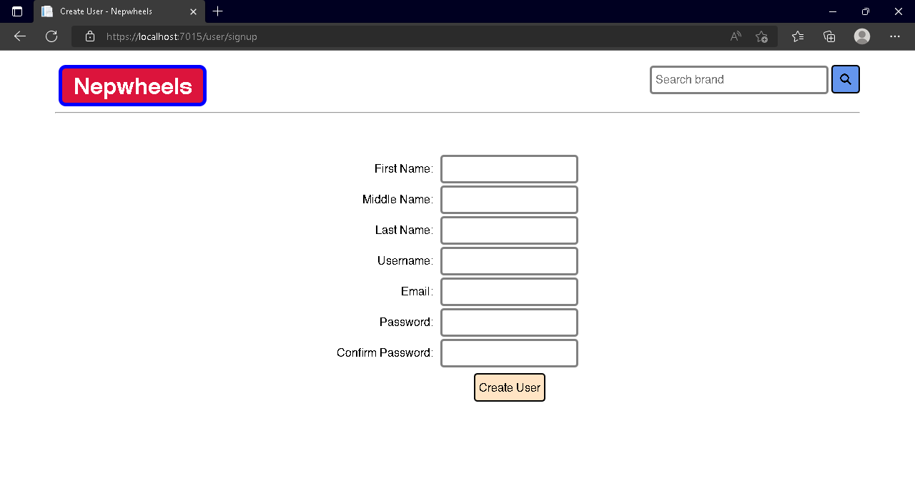

Screenshot 1: Signup page

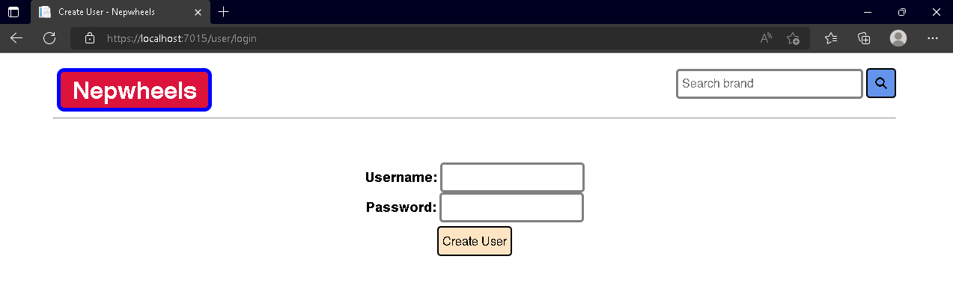

Screenshot 2: Login Page

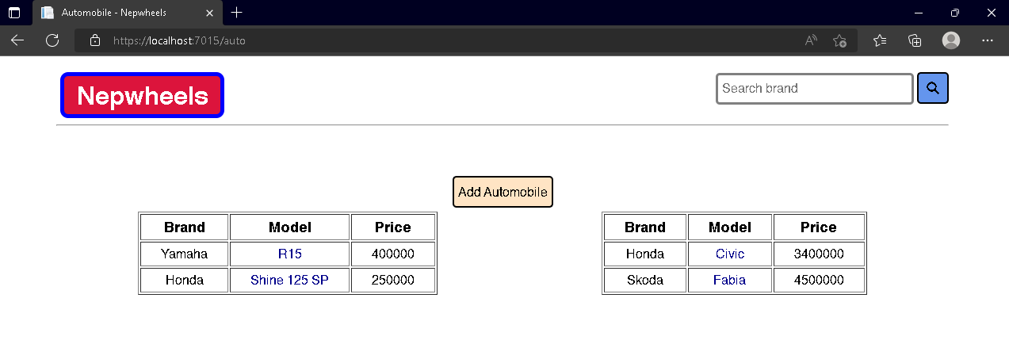

Screenshot 3: Main index

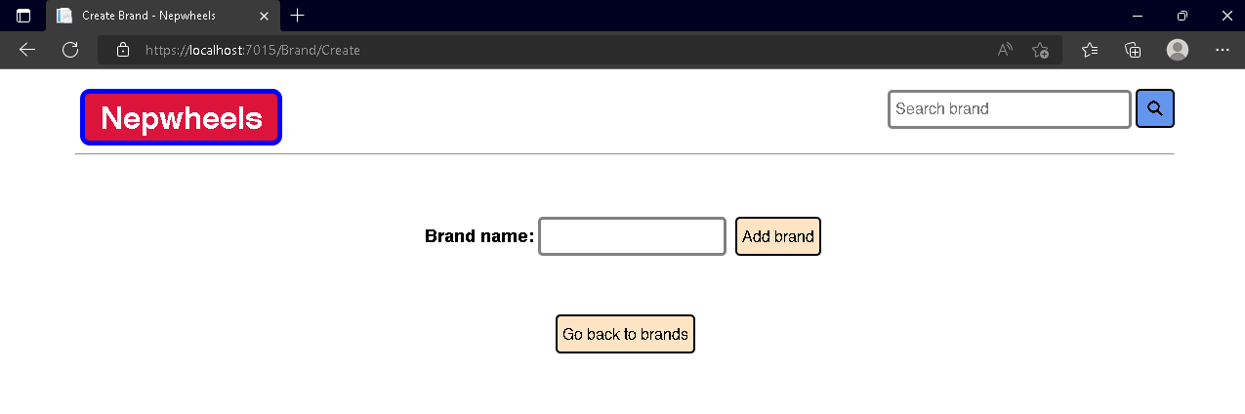

Screenshot 4: Add Brand

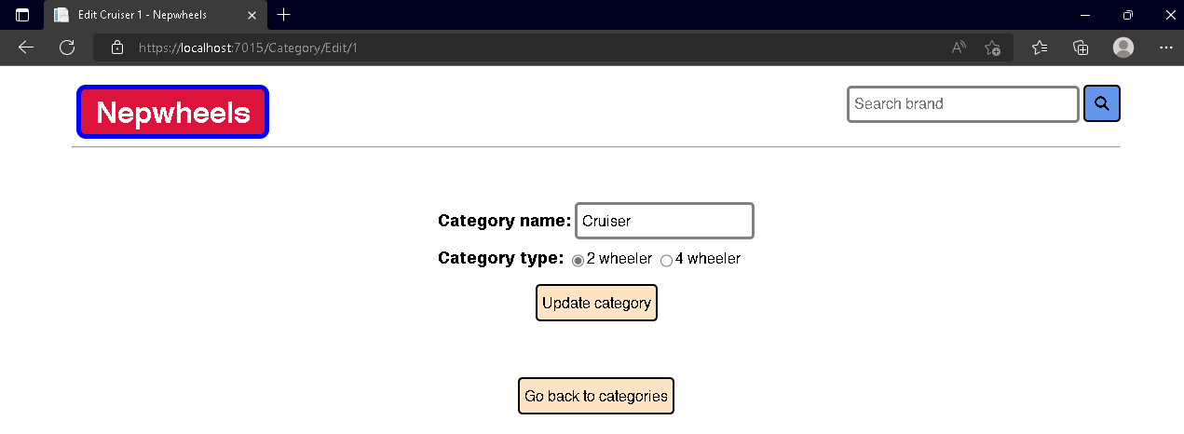

Screenshot 5: Edit category

# Conclusion

In this lab session, we learnt about routing Model-View-Controller patterns, Razor pages, template inheritance, and so on. We also started a small project implementation of these concepts. This lab session focused primarily on MVC patters, layouts, template inheritance, using views and rendering views using the Razor view engine, and tag-helpers. This lab session also marked the start of a mini project using ASP.NET core.